Name ____________________________________ Date __________________ Hr _________
Chapter 23-26 Guide
Vocab: Define each of the terms on your own paper.

- Tweed Ring
- Gilded Age
- Patronage
- Jim Crow laws
- Plessy v. Ferguson
- Chinese Exclusion Act
- Laissez-faire
- Interstate Commerce Act
- Vertical integration
- Horizontal integration
- Trust (business term)
- Standard Oil
- Social Darwinism
- Sherman Anti-Trust Act
- Knights of Labor
- American Federation of Labor
- New Immigrants
- Settlement houses
- Pragmatism
- Yellow journalism
- Women’s Christian Temperance Union
- Reservation system
- Battle of Little Big Horn
- Battle of Wounded Knee
- Dawes (Severalty) Act
- Populists
- Cross of Gold speech
- Gold Standard Act

Summary: Summarize each of the key concepts listed, then provide a short-paragraph (4-6 sentences) summary of the chapter.
- How did political machines, like the Tweed Ring for example, work?

- How does the cartoon reflect the practices of political machines?
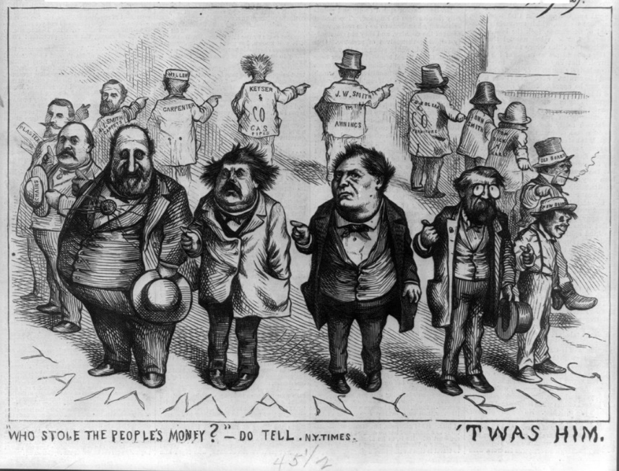
- How was the Chinese Exclusion Act supported by the decision in Plessy v. Ferguson?

- Why were people so against trusts? Why was a federal law needed to put an end to trusts?

- How does the cartoon represent the business practices of Standard Oil?
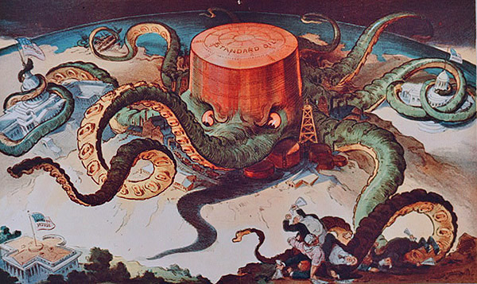
- Describe the average tenement house.

- How was yellow journalism use to influence the public?

- How did the Dawes Act mimic the Homestead Act while discriminating at the same time?

- It’s said the Populists wanted the STARS. What did they want?
S
T
A
R
S

- How does the cartoon exemplify both the Cross of Gold speech and the greater Populist cause?
