Extended Notes:
Unit 4: Forging an Industrial Society
Period 6: 1890-1945
“The American Pageant” Chapter 27
Underlined terms indicate previous vocabulary; bolded terms indicate new vocabulary.

Notes | Look here for extras!
As American industrialism continued to grow, it also began to change American values. America found that it was more than capable of taking care of itself, and started to look outward to spread its ideas, culture, and products. This was not a new idea in itself, as Europe had been doing this for centuries, but was a very new thing for the United States, and they would be in charge of how they handled situations similar to their own upbringing as a country.  The notion of imperialism was promulgated throughout the US in different ways.¹ At the newest forefront of American culture was the yellow press, who helped Americans envision international travel and acclaim as the new road to fame and glory over war. The likes of “Joseph Pulitzer and William Randolph Hearst described foreign exploits as manly adventures the kind of dashing derring-do that was the stuff of young boys’ dreams.” Various missionaries and others promoted the spread of American values and culture, while “trumpet[ing] the superiority of Anglo-Saxon civilization.” The growth of American businesses, transportation, and infrastructure begged to be let out of their bounds, creating a need for new markets. A new political meaning was given to Social Darwinism so that applied to entire countries, rather than individuals. This new definition was interpreted by politicians like Theodore Roosevelt and Henry Cabot Lodge to mean that whole societies could either adapt to the world or the world could take them over.² In relation many felt that the US needed to grow in order to protect itself. The first step in this was a brand new iron and steel-based Navy. This was furthered by an intensive study by Alfred Thayer Mahan in his book The Influence of Sea Power upon History, which argued that the whoever maintain control of the seas could maintain control of the world.  Prime examples of this new aspect to Social Darwinism emerged in Africa and China. In the 1880s, European powers gathered to split the land mass of Africa amongst itself.³ Known as the “scramble for Africa” countries like Britain and France scooped up territory there, along with new European powers like Germany, Italy, Belgium, and the Netherlands. Similarly, these powers began to set up spheres of influence along the coast of post-Opium War #2 China. These spheres gave these countries immense power and benefit over the area as China’s weakening government could not stop them. However, America took a different step in this direction with the Big Sister Policy in Latin America. This policy’s major purpose was to extend any kind of American trade. This less-aggressive approach to imperialism would mean some diplomatic tangles for the US—near wars with Germany and Italy, another hysteria against Great Britain that settled down with the Great Rapprochement.  American attitudes changed after these conflicts. Even though most had been settled with compromise, America did not want to feel like a second-place power. It’s only choice then was to become an imperial power. It looked first to the Pacific, continuing westward, and finally settled on a series of islands it had been in contact with before, Hawaii. Hawaii had a distinct culture, government, and economy of its own prior to interaction with white missionaries dating back to the late 1700s. Once imperialism took hold of the US in the 1890s, missionaries again became the first to travel to the islands. Seeing new and extended business opportunities, businessmen and their companies moved there next. This was an interesting move considering the McKinley Tariff, which raised barriers against Hawaiian products. The same planters who moved to Hawaii for business now sought to annex the small country on behalf of the US in effort to bypass the tariff.⁴ The staged a revolt in 1893, assisted by American troops nearby and managed to depose the Hawaiian government. Once this was done, they wrote to Congress claiming that Hawaii was ready to become a part of the US. Newly elected president Grover Cleveland ordered an investigation into American movements in HI after being tipped off that the US had been in the wrong. This put the annexation of HI on hold until 1898.  Around the same time of the annexation of HI, Cuba was ready to get rid of Spanish rule. Cuba had even destroyed parts of their own country and economy by burning large sugar-plantations and mills. While American sympathies went out to Cuba, the US being former colonies themselves, they were more interested in the $50 million they had invested in Cuban sugar. Spain moved in to confront the unruly Cubans through force. The yellow press picked up on this, printing sensationalized stories of atrocities in Cuba across front pages. One publisher even got a hold of a letter from a Spanish ambassador to his government in Spain. The de Lome Letter riled Americans much more than the sensationalized stories as it called then President McKinley weak and indecisive.  In February 1898, the US sent the USS Maine to Cuba to protect and evacuate Americans if necessary. Shortly after the ship’s arrival, it mysteriously exploded and sank. The yellow press claimed that this was the work of the Spanish, and an investigation was launched into the incident by both sides. Regardless of the findings, the US population was ready for war. President McKinley gave in to public pressure, and asked Congress to declare war. Included in the declaration of war was the Teller Amendment which stated that once the US “had overthrown Spanish misrule, it would give the Cubans their freedom.” This marked the beginning of the Spanish-American War.  The Spanish and American governments proceeded to send troops to Cuba. The US sent 17,000 confused troops to the island, which overwhelmed the Spanish troops. They met little opposition in Santiago. Similarly Teddy Roosevelt’s Rough Riders made it to the island, proving an actual challenge with their charge up San Juan Hill. While the Spanish could have waited for the US to succumb to the humid climate and its diseases, many troops fled leaving Santiago to surrender. The US then made plans to go after other Spanish colonies, including Puerto Rico, and to continue fighting Spanish forces in the Philippines.  The US Navy had been the first to encounter the Spanish in the Philippines. Upon hearing of the declaration of war, Commodore John Dewey and the US fleet at Hong Kong were given orders to move to the Philippines. This fleet was able to surround the Philippines and push back—and destroy parts of—their Spanish counterpart. The only problem Dewey encountered was his lack of ability to invade since he only had ships and sailors. He continued to blockade the area, keeping it from the Spanish and other European powers, until land-based reinforcements arrived later. Once these troops arrived, they were able to invade and capture the capital city of Manila with the assistance of Filipino troops. The US used HI as a go-between and resupply point for troops in the Philippines, causing the official annexation to pass through Congress. Once the Spanish were out of the Philippines, an end to the war was set. The Spanish-American War had ended after only 113 days.  The US became a full-fledged imperial power at the end of this war, as they had officially taken over territory. First Hawaii but also the Philippines. Upon capturing Manila, the US forces turned on Filipino troops to make the Philippines a US colony after Congress passed a bill of annexation. The rationale behind this was simply that the US could not let go of the Philippines. They could return the territory to Spain, nor could they let another power take control of it. They also didn’t think that the Philippines would make it on their own in this respect. The plan was then “to acquire all the Philippines and then perhaps give the Filipinos their freedom later.” Fighting did not exactly stop in the Philippines as much as it took a break. The Philippine Insurrection was put down in 1901, after some serious guerilla warfare and the massacre of some 250K Filipinos.  The US acquired other territory at the end of the war as well. As part of the treaty negotiations, the US received Puerto Rico and Guam. The US granted PR citizenship and promised eventual statehood, but has yet to deliver, even in 2019. Cuba also made its way into American hands. In 1902, the US withdrew the Teller Amendment in favor of the Platt Amendment, which kept Cuba under partial US control until 1934.  Anti-Imperialist sentiment grew as the US began to acquire territory. The Anti-Imperialism League argued the imperialism would invite tyranny into the US. They continued by saying that imperialism was too costly for an newly industrialized nation, and that trade with these places should be the priority rather than making them a part or possession of the US. The League was a diverse enough group that the influential members involved could sway some of the general public to their side. The pro-imperialist stance, though not equipped with well-known names, supplied logical arguments while ignoring those of the anti-imperialists. Pro-imperialists argued that imperialism would keep the US on the world stage and make them a world power. They stated that owning the country would not only give the US new markets for trade, but also new natural resources that they wouldn’t have to import. They were further influenced by Rudyard Kipling’s poem, “The White Man’s Burden”, which called imperialism a “civilizing mission” and inspired the “wealthy Americans…to uplift (and exploit) the underprivileged, underfed, and underclad of the world.”  Meanwhile, the US took a different approach when it came to China. Having a colony in Asia meant that the US was poised to interact with Asian powers like China and Japan on a regular basis. The policy the US decided to extend to China was much different than what Europe had offered. The Open Door Policy was not an imperialist policy but a trade policy. It respected China’s autonomy and rather than establish an American sphere of influence, it offered better trade regulations between the two countries. The rest of Europe was skeptical, but China responded well even though they were not keen on western powers taking advantage of them. This was demonstrated by the Boxer Rebellion, a large nationalist movement that focused on dispelling non-Chinese influence.  After William McKinley’s assassination in 1901, Theodore Roosevelt became president. Roosevelt had a strong personality—you either loved him or hated him, but there was no way to ignore him. He had no interest in the checks and balances within government, but kept the Constitution close to promote the exercise of presidential implied powers. In this respect, he favored imperialism. His diplomatic policy followed his favorite proverb: Speak softly and carry a big stick, and you will go far. It served as the inspiration for the “Big Stick” Policy which continued US diplomacy with other countries, but also kept them prepared in case of a threat, or if they needed to pose a threat of their own.  One of TR’s priorities was to finish a canal project that had started in Central American decades earlier. The Sp-Am War had rekindled interest in the idea of a canal⁵ would increase shipping between the Atlantic and Pacific as well as decreasing possibly military response and travel times. For the US, it would mean easier defense of newly acquired territories. The US made moves to secure permission to the area from the British first, as per a stipulation within the Clayton-Bulwer Treaty, which would be done via an updated version known as the Hay-Pauncefote Treaty in 1901. They then had to get clearance from the French construction company that had started building the canal earlier, which they did after paying $40 million. A canal was set to be built in Panama. But there was one more problem, Panama was technically a part of Colombia. Congress proposed a deal with Colombia for use of the land of an initial payment of $10M and a yearly payment of $250K. This offer was rejected, and the US began to incite the Panamanians to rebel—something they had done before and would not take much convincing to do again. Within days of the rebellion officially starting, the US acknowledged Panama as its own country. Construction of the canal began the next year in 1904.  “Latin American debt defaults prompted further [US] involvement” with South and Central America. “Roosevelt feared that if the Germans or British got their foot in the door as bill collectors,” it would only be a matter of time before they started to colonize the area again, this time as punishment for nonpayment. Roosevelt decided that preventative measures must be taken, and the policies of the Monroe Doctrine were extended. This addition, the Roosevelt Corollary, “announced that in the event of future financial malfeasance by the Latin American nations, the United States itself would intervene” to make sure things were taken care of in a reasonable manner for all parties involved. This would make the US a police power in the western hemisphere and completely rule out any future imperial prospects of Europe in the area, while keeping alive the imperial prospects of the US.  Roosevelt also got involved with the Russo-Japanese War in 1905, diplomatically rather than militarily though. The war was crucial for both Russia and Japan, who each had their eyes on new, resource rich territories they could add to their prospective empires. Much to everyone’s surprise, Japan won, taking some of Russia’s “world power-ness” away from them. TR was asked to help with negotiations to end the war. The resulting Portsmouth Treaty satisfied no one but TR: he was able to avoid a collapse of the Russian Empire so it could stay in place to counterbalance Japan’s growing empire. No one got the land they had been hoping for, and relations between the US and Russia, and the US and Japan suffered. Friendship between the US and Japan withered to the point of intense domestic discrimination against Japanese immigrants. Japanese immigrants at the time made up a fair portion of the labor force in California and 3% of the overall population. Things got so bad, the US and Japan met again to resolve the issue with a “Gentlemen’s Agreement” that would decrease both incidents of discrimination and Japanese immigration to the US. This was further in a more formal way with the signing of the Root-Takahira Agreement, under which both countries vowed to respect each other’s territories in the Pacific. | CAUSES OF AMERICAN IMPERIALISM:  - Yellow Journalism  - The need for new markets  - The want to spread American values and religions.  - Social Darwinism  - Protection  2. Imperialism implied the use of force, while colonization may or may not need force.  The Influence of Sea Power upon History (1890): influential book written by Alfred Thayer Mahan which chronicled naval strategies relating to the rise of the British Empire.  Read it here.  3. 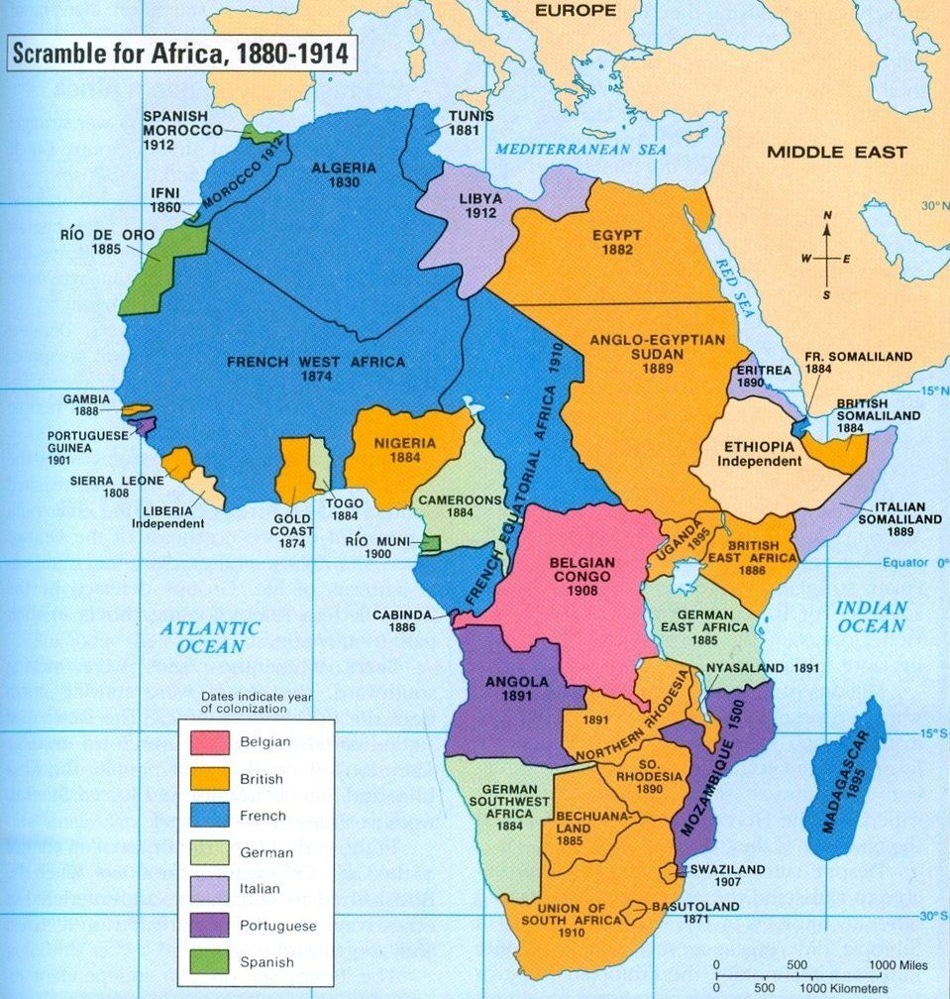  Spheres of influence: an area of a country over which a separate country has the power to influence and determine developments though they have no formal authority.  Big Sister Policy: US foreign policy aimed at rallying Latin American nations behind American leadership and opening Latin American markets to the US.  Great Rapprochement: the beginning of a close, cordial relationship between the US and Britain.  McKinley Tariff (1890): tariff which raised duties on Hawaiian sugar and set off renewed efforts to secure the annexation of HI.  4. This was primarily led by the Dole Fruit Company who relied on HI’s fruit for their business. Dole conspired with other planters in the area to form the Committee of Safety, who then conspired to annex the islands for their own benefit.  The de Lome Letter (1898): letter written by Spanish Ambassador to the US E.D. de Lome to another Spanish government official that criticized US President William McKinley by calling him weak and indecisive.  USS Maine: US naval ship that was sent to Havana, Cuba just in case Americans there would need to be evacuated which mysterious sank in February, 1898.  Teller Amendment (1898): a proviso to McKinley’s was plans that proclaimed to the world that the US would give Cuba its freedom once it had overthrown Spanish misrule.  Spanish-American War (1898): military conflict between the US and Spain that took place in Spanish colonies near the US and ended Spanish colonial rule.  CAUSES FOR THE SP-AM WAR:  - The sinking of the Maine  - US investments in Cuba  - Yellow journalism  - The de Lome Letter  Rough Riders: regiment of war volunteers led by Teddy Roosevelt with experience and moxie rather than discipline.  TERRITORIES GAINED BY THE US:  - The Philippines  - Guam  - Puerto Rico  - Cuba  REASONS THE US JUST HAD TO KEEP THE PHILIPPINES:  - Another source of new markets  - Didn’t want to hand them over to anyone else  - Didn’t feel they would make it on their own  - Would have multiple colonies in the Atlantic and Pacific  Philippine Insurrection (1901): uprising within the Philippines against American rule.  Platt Amendment (1901): amendment within the Cuban constitution that limited its treaty-making ability, controlled its debt, and stipulated that the US could intervene militarily to restore order as they saw fit.  Anti-Imperialism League: diverse group formed to protest American colonial oversight in the Philippines that became the largest lobbying organization on a foreign policy.  “The White Man’s Burden” (1899): poem by British author Rudyard Kipling that encouraged specifically American imperialism as a “civilizing mission”.  Open Door Policy (1899-1900): US foreign policy which sought to ensure access to the Chinese market for the US without creating an American sphere of influence there.  Boxer Rebellion (1900): uprising in China directed at foreign influence later suppressed by an international conglomerate of troops but not before paving the way for further revolutions in China.  “Big Stick” Policy: foreign policy under Theodore Roosevelt which promoted the idea of being able to negotiate peacefully but also having strength in case something were to go wrong.  5. A French company was initially responsible for building the canal but didn’t get very far thanks to in adequate tools and lack of immunity for local diseases.  Hay-Pauncefote Treaty (1901): treaty signed between the US and Britain giving America a free hand to build a canal in Central America; the treaty nullified the Clayton-Bulwer Treaty.  Roosevelt Corollary (1904): a brazen policy of “preventative intervention” advocated by TR as an addition to the Monroe Doctrine which stipulated the US would retain a right to intervene in the domestic affairs of Latin American nations in order to restore military and financial order.  “Gentlemen’s Agreement”: handshake agreement between the US and Japan in order to decrease incidents of discrimination in the US against Japanese immigrants while also decreasing the number of Japanese immigrants that were coming to the US.  Root-Takahira Agreement (1908): agreement between the US and Japan to respect each other’s holdings in the Pacific, as well as maintain the Open Door Policy.

