Name _____________________________________ Date_______________ Class Hour __________

AP US History DBQ: Manifest Destiny

Directions: The following question is based on the attached documents. As you analyze the documents, take into account both the source of the document and the author’s point of view. Using what you learn from the documents, and your own knowledge of the topic, answer the essay question with a minimum of five (5) paragraphs.

Be sure to:
- Include a thesis that answers all parts of the question.
- Support your argument with evidence from the documents.
- Use the documents, putting them in context with the question and each other. It is not good enough just to reference them.
- Write a well-organized essay that proves your thesis. I know you only have so much time here, but make sure your essay “flows” in a logical pattern and uses the documents along with your own knowledge.

Question: How did the idea of Manifest Destiny change the American political, social, and economic landscapes by the 1860s?

Document A:
John L. O’Sullivan on Manifest Destiny, 1839.
“The American people having derived their origin from many other nations, and the Declaration of National Independence being entirely based on the great principle of human equality, these facts demonstrate at once our disconnected position as regards any other nation; that we have, in reality, but little connection with the past history of any of them, and still less with all antiquity, its glories, or its crimes. On the contrary, [our] national birth was the beginning of a new history, the formulation and progress of an untitled political system, which separates us from the past and connects us with the future only; and so far as regard the entire development of the natural rights of man, in moral, political, and national life, we may confidently assume that our country is destined to the great nation of futurity.”

Document B:
Manifest Destiny
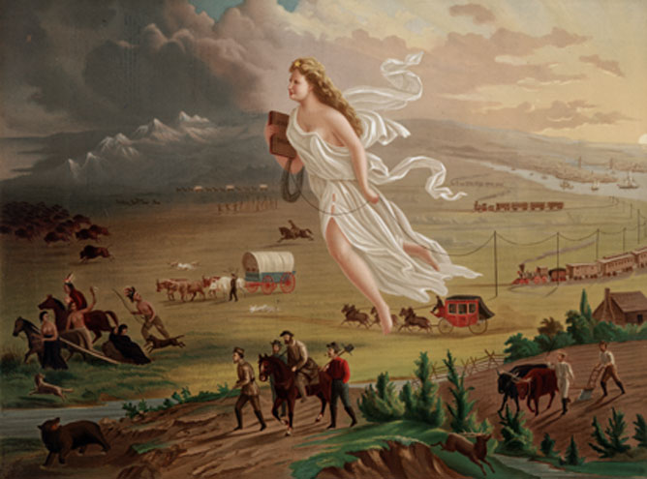

Document C:
Congressional resolution to annex Texas, 1845.
“Resolved by the Senate and House of Representatives of the United States in Congress assembled, That Congress doth consent the territory and property included within, and rightfully belonging to the Republic of Texas, may be erected into a new State, to be called the State of Texas, with a republican form of government, to be adopted by the people of said republic, by the deputies in convention assembled, with the consent of the existing government, in order that the same may be admitted as one of the States of the Union.
And be it further resolved, That the foregoing consent of Congress is given upon the following conditions, and with the following guarantees to wit:
First said state be formed, subject to the adjustment by this government of all questions of boundary that may arise with other governments; and the constitution thereof, with the proper evidence of its adoption by the people of said Republic of Texas, shall be transmitted to the President of the United States, to be laid before Congress for its final action, on or before the first day of January, one thousand eight hundred and forty-six.”

Document D:
Map of Disputed Texas Border
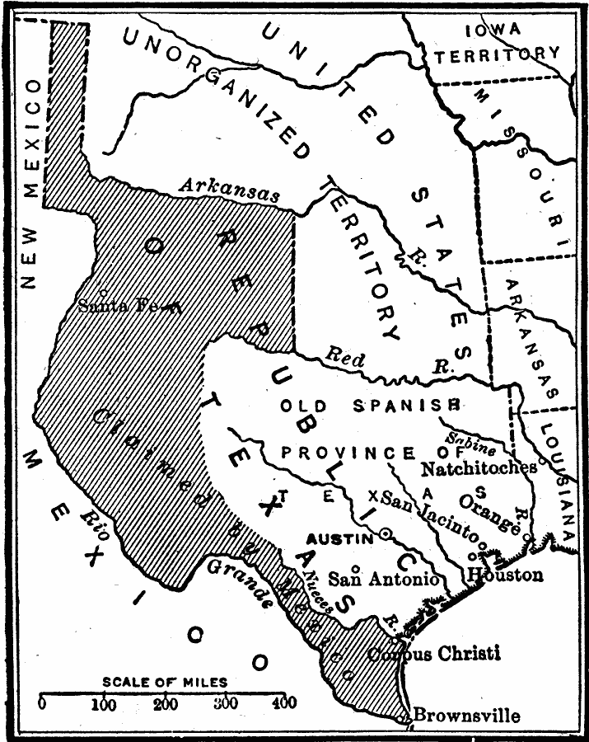

Document E:
Declaration of War on Mexico by President James K. Polk, 1846.
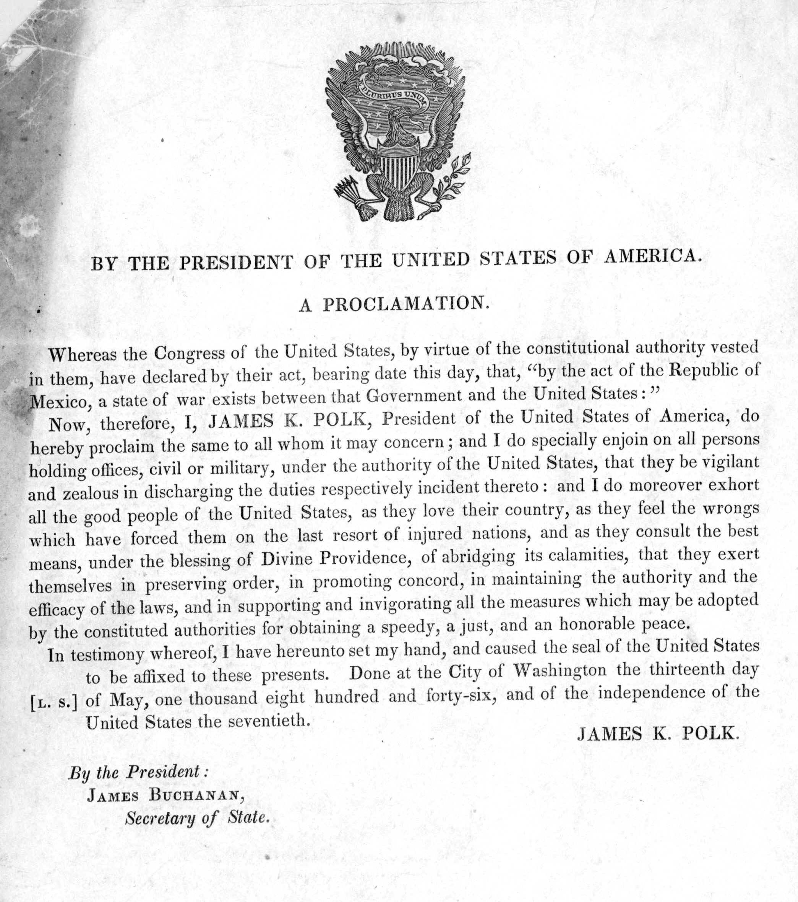

Document F:
Article V of the Treaty of Guadalupe Hidalgo
“The boundary line between the two Republics shall commence in the Gulf of Mexico, three leagues from land, opposite the mouth of the Rio Grande, otherwise called Rio Bravo del Norte, or opposite the mouth of its deepest branch, if it should have more than one branch emptying directly into the sea; from thence up the middle of that river, following the deepest channel, where it have more than one, to the point where it strikes the southern boundary of New Mexico…to its western termination; thence northward along the western line of New Mexico, until it intersects the first branch of the River Gila…until it empties in to the Rio Colorado; thence across the Rio Colorado, following the division line between upper and Lower California, to the Pacific Ocean.
The southern and Western limits of New Mexico, mentioned in the article are those laid down in the map entitled “Map of the United Mexican States, as organized and defined by various acts of the Congress of said republic and constructed according to the best authorities. Revised edition. Published at New York in 1847, by J. Disternell,” of which map a copy is added to this treaty, bearing the signatures and seals of the undersigned….And in order preclude all difficulty in tracing upon the ground the limit separating Upper from Lower California, it is agreed that the said limit shall consist of a straight line drawn from the middle of the Rio Gila, where it unifies with the Colorado. To a point on the coast of the Pacific Ocean, distant [to one] marine league due south of the southernmost Point of the port of San Diego, according to the plan of said port made in the year 1782 by Don Juan Pantoja, second sailing master of the Spanish fleet, and published at Madrid in the year 1802, in the atlas to the voyage of the schooners Sutil and Mexicana; of which a plan copy is hereunto added, signed and sealed by the respective [dignitaries].”

Document G:
Ad for Prayers on behalf of John Brown.
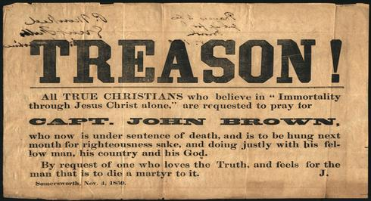

Document H:
Map of the US by 1860 (including railroads)
(Image on next page)
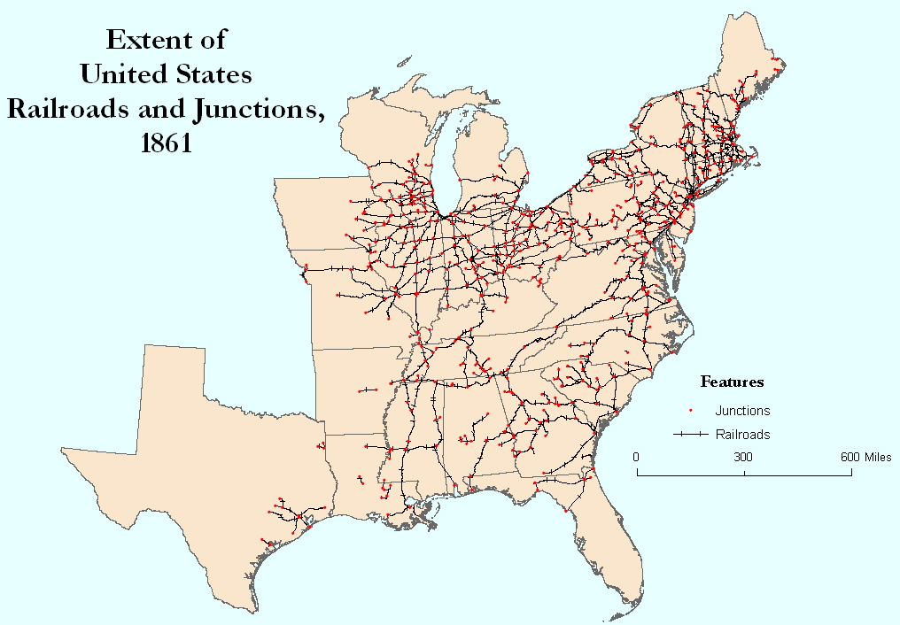
Document J:
The Freeport Doctrine by Stephen A. Douglas, 1858.
“The next question propounded to me by Mr. Lincoln is, Can the people of a Territory in any lawful way, against the wishes of any citizen of the United States, exclude slavery from their limits prior to the formation of a State constitution? I answer emphatically, as Mr. Lincoln has heard me answer a hundred times from every stump in Illinois, that in my opinion, the people of a Territory can, by lawful means, exclude slavery from their limits prior to the formation of a State constitution. Mr. Lincoln knew that I had answered that question over and over again. He heard me argue on the Nebraska bill on that principle all over that State in 1854, in 1855, and in 1856, and he has no excuse for pretending to be in doubt as to my position on that question. It matters not what way the Supreme Court may hereafter decide as to the abstract question whether slavery may or may not go into a Territory under the Constitution, the people have the lawful means to exclude it as they please, for the reason that slavery cannot exist a day or hour anywhere, unless it is supported by local police regulations. Those police regulations can only be established by the local legislature; and if the people are opposed to slavery, they will elect representatives to that body who will, by unfriendly legislation, effectually prevent the introduction of it in to the midst. If on the contrary, they are for it, their legislation will favor its extension. Hence, no matter what the decision of the Supreme Court may by on that abstract question, still the right of the people to make a Slave Territory or a Free Territory is perfect and complete under the Nebraska bill. I hope Mr. Lincoln deems my answer satisfactory on that point.”

